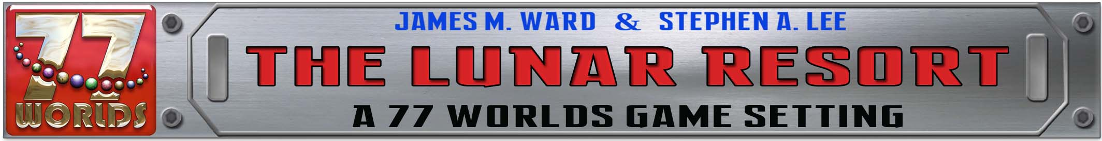
77worlds.com: Character Sheet Sketch
Creation Cards

Note: Consult character creation table to determine Character Type
NAME: Character:
Origin: Entity:
Character Abilities:

Character Rank Quest Completed

Equipment Location: (Easy to Reach on belts or bandoleers?)
1)
2)
3)
4)
5)
6)
7)

Background & Notes:

Character Attack & Defense Sheet

Creation Cards Attacking
Current Rank
# of cards to Draw

Entertainer Points
ΟΟΟΟΟ ΟΟΟΟΟ ΟΟΟΟΟ
ΟΟΟΟΟ ΟΟΟΟΟ ΟΟΟΟΟ

Current ΟΟΟΟΟ ΟΟΟΟΟ ΟΟΟΟΟ
Health ΟΟΟΟΟ ΟΟΟΟΟ ΟΟΟΟΟ
ΟΟΟΟΟ ΟΟΟΟΟ ΟΟΟΟΟ
ΟΟΟΟΟ ΟΟΟΟΟ ΟΟΟΟΟ
ΟΟΟΟΟ ΟΟΟΟΟ ΟΟΟΟΟ
Shield(s): Special Defense Attributes
ΟΟΟ ΟΟΟΟΟ ΟΟΟΟΟ S1:
ΟΟΟ ΟΟΟΟΟ ΟΟΟΟΟ S2:
Armor: A1:
ΟΟΟΟΟΟΟ ΟΟΟΟΟΟΟ A2:
ΟΟΟΟΟΟΟ ΟΟΟΟΟΟΟ A3:
Range/ Heart Diamond Special
Weapon Type Damage Damage Attributes

